DailyMile registration

Made 23.07.2018.

To use the API of DailyMile, you need to generate API credentials.

1. Go to <https://www.dailymile.com/signup>, enter information about you and click SignUp.

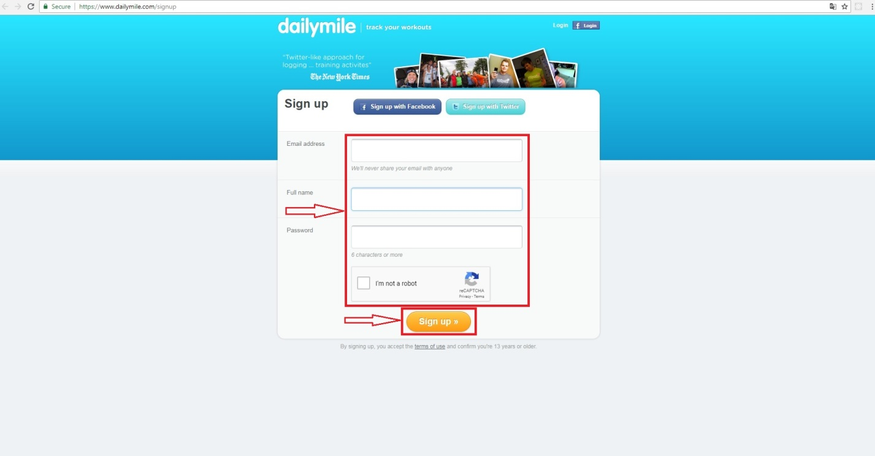

1. You can add you friends in your account or skip this step.



1. You can add your foto to account or skip this step.



1. Go to <https://www.dailymile.com/api/consumers/new> enter information about yours app click Register.

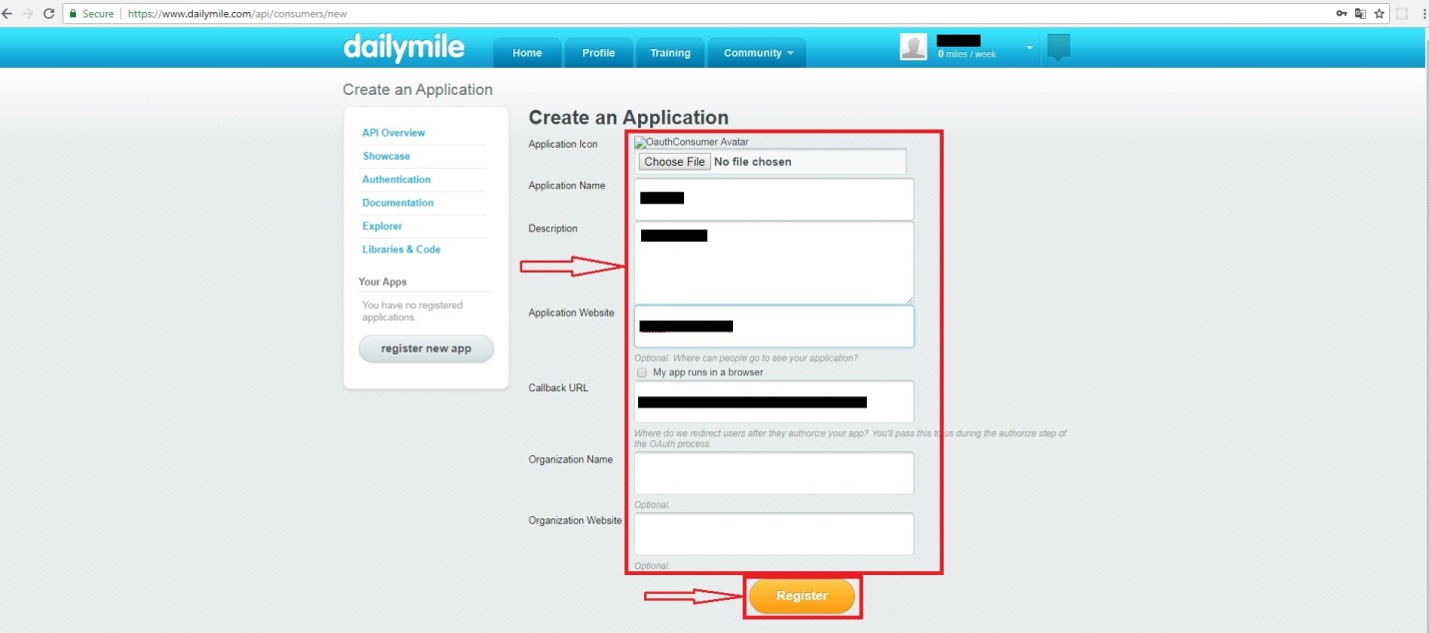

1. And you can use API credentials for your App.

